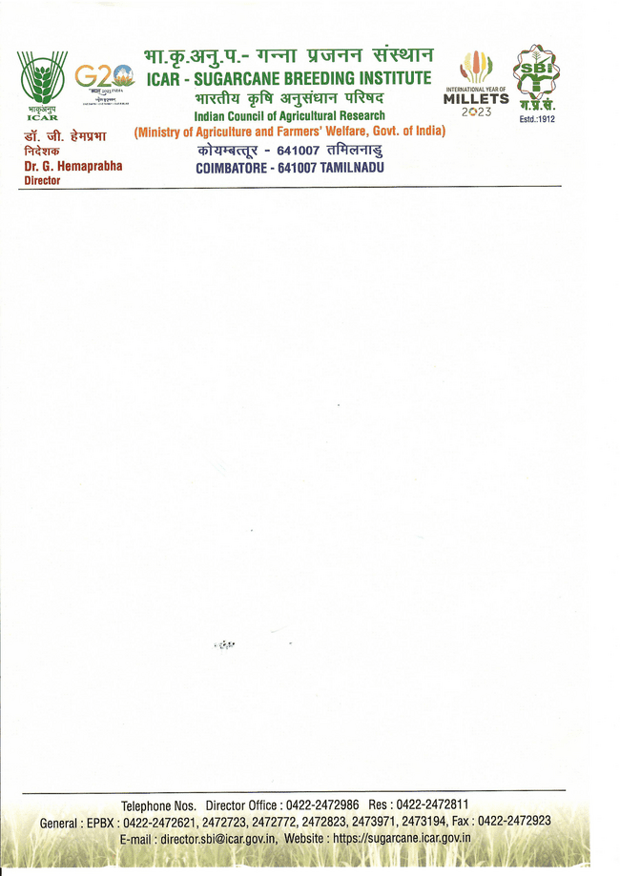

**TERMS AND CONDITIONS FOR BOOKING AN ACCOMMODATION AT ICAR-SBI**

**GUEST HOUSE**

* Allotment of rooms in the Guest House shall be on the first come first serve basis. However, preference will be given for ICAR/DARE Officials coming on official tour.
* Submission of copy of valid identity card is a must for all the guests seeking accommodation in the guest house, to ascertain their identity.
* To avoid inconvenience, request for allotment of accommodation should be sent well in advance, or at least two working days prior by using application form which is available in the website through email [**guesthome.sbi@icar.gov.in**](mailto:guesthome.sbi@icar.gov.in)

**No verbal/telephonic request will be entertained.**

* Maximum Continuous stay in the Guest House would be for a period of 15 days subject to availability.
* Allotment can be cancelled/shifted in case it is required for VIP use/exigency.
* The room rent charges shall be applicable as per the status of the guest staying in the guest house and not as per the status who has booked the accommodation e.g. if an ICAR employee is booking an accommodation for a private person, charges will be applicable to **"Private visitor** and not **"ICAR Charges"**
* VIP guests of Ministry of Agriculture (Union as well as the State) and the Director General, ICAR will be charged as ICAR official category rates only when a written request is received from their office or else they will be charged as per their actual category.
* Liquor/smoking is strictly prohibited in the Guest House.
* Pets are not allowed in the Guest House.
* Proper decorum in the Institute and Guest house should be maintained. Guest House In-charge reserve the right to withdraw the lodging facilities of the Guest if found not maintaining proper decorum or creating a nuisance to others.
* Any loss to the Govt. Property by the visitors in and around the Guest House premises, including breakage of crockery etc., will be recovered from the Guest by the Guest House In-charge instantly.
* Room rents and other charges are to be paid to the Guest House staff before checking-out.
* Food serving time: Breakfast – 8am to 9am, Lunch – 1pm to 1.30 pm, Dinner – 8 pm to 9pm.

Website: **www.sugarcane.icar.gov.in **

Email: [**guesthome.sbi@icar.gov.in**](mailto:guesthome.sbi@icar.gov.in) S B BABURAJ

In-Charge Guest House